Organizational Quality Processes Manual QSM-9000

Revision History and Approval
Rev | Date | Paragraph | Page | Revision Summary | Approved
- | 01 Aug 2024 | All | All | Creation and incorporation of previous manual to align with AS9100 and Identified company needs

Contents
Organizational Quality Processes Manual QSM-9000 1
Revision History and Approval 1
1. INTRODUCTION 2
2. The Organization’s MISSION – VISION – VALUES STATEMENT 2
3. About The Quality Manual 3
4. Context of The Organization 3
(Exclusions): 3
• 8.3 Design and Development of Products and Services: This exclusion applies to all locations except Riverside and Phoenix, as they include the Laser Department for limited design feedback. 3
5. Leadership 3
6. Planning 4
7. Support 4
8. Operation 5
9. Performance Evaluation 7
10. Improvement 7
11. Figures and Process Maps 8

INTRODUCTION
This manual describes the Quality Management System, delineates authorities, interrelationships, and responsibilities of the personnel responsible for performing within the organizations system providing procedures or references for the activities comprising the Quality Management System. Ensuring conformance to the necessary requirements of ISO9001, AS9120, AS9100, and AS6174A standards where appropriate, and is used both internally and externally as an introduction to the QMS.
With more than 70 years in business and 7 locations we have become one of the largest and most efficient metal service centers in our industry, meeting the needs of businesses and hobbyists. Our organization helps customers by providing the most responsive and reliable high-quality service across multiple states including California and Arizona.
We offer the largest selection of metals to businesses via a unique three-fold distribution channel – Next day delivery, same-day Will Call, and stores that are open six days a week. Our organization focuses on making metal easy for our customers and will continue to add automation and efficiencies to save them time and money.

The Organization’s MISSION – VISION – VALUES STATEMENT
We are committed to providing ALL customers with the most responsive, highest quality, and reliable service in our industry. Our organization’s associates pride themselves on doing things right the first time. We value learning, encourage innovation, and welcome change. We maintain the highest standards of integrity with our customers and suppliers, with profit levels that promote growth and a favorable return to our associates and the company.
QMS Management Representative |  | Date:

About The Quality Manual
This manual is prepared for the purpose of defining the company’s interpretations of the AS9120, AS9100, AS6174A, and ISO 9001 international standards, as well as to demonstrate how the company complies with that standard.

Context of The Organization
Understanding The Organization and Its Context
Our organization consists of Industrial Metal Supply with 6 locations that specialize in Metal Sales and Cutting Services, specializing in Metal Sales and Precision Aluminum Sheet & Plate Cutting, Stainless Bar Cutting, Circle & Ring Cutting from Plate.
Our branches stock domestic and import high-quality aluminum, steel and stainless steel in many alloys, shapes, and sizes, including custom aluminum extrusion requests. In addition, the stores in California and Arizona offer thousands of specialty metals, accessories, tools, and remnants. The table included as figure 1 captures the needs and expectations as defined by The Organization.
Due to our limited impact on Environmental factors related to Climate Change, IMS and its interested parties do not currently have any requirements stated. If at such time our customers require Climate change to be integrated into our processes, IMS will take that into consideration.
Determining the Scope of the Quality Management System
The Organization has determined the scope of the quality management system as follows:
Scope: - Mill Distributor and Full Line Metal Service Center of a Variety of Metals, Including Aluminum, Steel, Stainless Steel, Tool Steel, Brass, Copper, Silicon Bronze, and Lead, along with Specialty Catalog Items, such as Railing Systems, Decorative Brass and Ornamental Iron
The Organization’s Quality Management System applies to all functions and sites as applicable.
The following clauses of AS9120 were determined to be not applicable to The Organization.

(Exclusions):

8.3 Design and Development of Products and Services: This exclusion applies to all locations except Riverside and Phoenix, as they include the Laser Department for limited design feedback.
- 8.5.3 Customer Property: Previously excluded, but now included for the Riverside and Phoenix locations as the organization handles customer-owned materials (drawings or engineering documents) specific to the Laser department Quality Management System and Its Processes

Key Processes Identified
The Organization uses a process approach for its quality management system and has identified the top-level processes within the organization.
This reduces the potential for nonconformities discovered during final processes or after delivery.
The top-level processes identified for The Organization are Quality, Sales, Procurement, Warehouse Operations, and Logistics.
Each process may be supported by other activities. Monitoring and control of top-level processes ensures effective implementation and control of all subordinate tasks or sub-processes. Each top-level process is included in the Process Flow Diagram.
The sequence of interaction of these processes is illustrated as figure 2 at the end of this document.

Leadership

Leadership, Commitment and Customer focus
Top Management of The Organization provides evidence of its leadership and commitment to the development and implementation of the management system and continually improving its effectiveness.
This is reviewed at least annually and is defined in the Management Review process ensuring the requirements of the standard and interested parties are maintained.
The Quality Policy, Objectives, strategic direction of the company, interested parties, and opportunities for improvement are used to measure the effectiveness of the Quality System where applicable.
Top Management of The Organization has adopted a customer-first approach which ensures that customer needs and expectations are determined, converted into requirements, and are met with the aim of enhancing customer satisfaction.
The Organization’s Quality Policy
“The employees of Industrial Metal Supply are committed to continuous improvement, and meeting customer and stakeholder requirements with the most accurate, responsive, reliable, and convenient service available.”
Organizational Roles Responsibilities and Authorities
Top Management has assigned responsibilities and authorities for all relevant roles in the company. These are communicated through the combination of The Organization’s Chart (Figure 3) and Position Descriptions.
The DOQ has been assigned the role of Management Representative.
The Management Representative shall also be responsible for maintaining and updating the QMS when required, taking into consideration those customer, Regulatory, and Standard requirements.
Other duties of the Management Representative may be defined herein or within other documented procedures.

Planning
Actions to Address Risks and Opportunities
The Organization considers risks and opportunities when taking actions within the management system, as well as when implementing or improving the management system; likewise, these are considered relative to products and services. Risks and opportunities are identified and managed through Management review and are recorded. Risks are managed to minimize their likelihood and impact; opportunities are managed to improve their likelihood and benefit.
Quality Objectives and Planning to Achieve Them
As part of the adoption of the process approach, The Organization utilizes its process objectives, as the main quality objectives for the QMS. These include overall product-related quality objectives; additional product-related quality objectives may be defined in work instructions or customer requirements.
The process objectives have been developed by Top Management to capture the success of the QMS. This is reviewed during Management Review at least annually.
Process quality objectives are planned, reviewed, and recorded in the minutes of management review by members of Top Management.
Planning of Changes
Changes to the quality management system and its processes, including the structure, documented information, quality culture, and continuous improvement are carried out in a planned manner and documented.
When planning changes to the Quality Management System, Top Management considers any potential impact from Regulatory or customer requirements, how that change will affect the QMS, the availability of Resources and any other additional Risks identified and recorded during Management Review.

Support
Resources
The Organization determines and provides the resources (People, Tools, Equipment, Processes, and other identified inputs) needed to implement, improve, and maintain the management system
Resources and resource allocation are assessed during management reviews.
People
Top Management ensures sufficient staffing for the effective operation of the management system, as well its identified processes, and reviews this information during the scheduled management review meetings documenting any required changes.
People are considered a key resource and are selected based on skillset. Whenever identified as a need, those people are trained as appropriate.
Infrastructure
The Organization determines, provides, and maintains the infrastructure needed to achieve conformity to product requirements. Infrastructure includes, buildings, workspace, associated facilities, process equipment, supporting services such as transport, as well as information and communication technology.
Environment for the Operation of Processes
The Organization provides a suitable work environment to achieve conformity to product requirements and manages that work environment on an on-going basis to ensure the necessary conditions are maintained.
Monitoring and Measuring Resources
Where equipment is used for critical measurement activities, such as inspection and testing, these are subject to control and either calibration or verification and personnel are trained to understand these requirements.
Organizational Knowledge
The Organization determines the knowledge necessary for the continued operation of its processes and to achieve conformity of products and services. Whenever identified, this knowledge is captured in a manor suitable to be shared with the appropriate interested party. This knowledge shall be maintained and made available to the extent necessary.
Competence/Awareness/Communication
Staff members performing work affecting product quality are competent based on appropriate education, training, skills, and experience.
Employees are made aware of their impact on the QMS, and safety and The Organization communicates this through all levels of the organization.
Documented Information (Manuals, Procedures, Work Instructions, and Forms)
The Organization’s Quality Management System consists of documented information and listed on the Master List of Documents.
Documents required for the management system are Controlled.
Document Configuration consists of Top Level - Manuals, 2nd Tier - Procedures, 3rd Tier - Forms, and 4th Tier - Work Instructions and attachments.
The numbering of these documents is designed to reflect the relevant areas of the ISO9001/AS9120 standards and this manual.

Operation

Operational Planning and Control
The Organization plans and develops the processes, Procedures, work instructions, training documents, process flows and other identified documentation, for the realization of its Products and/or Services in order to deliver quality product that conforms to the customers requirements.
Planning of Product or Service realization is consistent with the requirements of the other processes of the quality management system and takes into consideration the needs and expectations of Interested Parties.

When identified as necessary, changes to planning and processes are implemented and flowed down to the employees.

Configuration Management
The Organization plans, implements, and controls configuration management activities (see Figure 2) as appropriate to its Products or Services to ensure the identification and control (traceability) of physical and functional attributes throughout the product life cycle.
Product Safety and the Requirements for Products and Services
The Organization has implemented processes for Product Safety and requirements for Products and Services to support interested parties and standards requirements when required.
Customer Communication
The Organization has implemented effective communication with customers in relation to products and services, changes to orders, feedback, and relevant contingency actions.
Determining the Requirements Related to Products and Services
During the intake of new business, The Organization considers the requirements of the customer, regulatory, and any other defined requirements, stated or unstated but necessary for the fulfillment of the order. The Organization further takes into consideration the use of state-of-the-art processes and services, Risk, and other possible factors that could impact quality or delivery of the agreed product or service.
Review of Requirements Related to Products and Services
The Organization reviews Purchase Order requirements prior to its commitment to supply Product or Services.
Changes to Requirements for Products and Services
The Organization updates all relevant requirements and documents when the requirements are changed and ensures that all appropriate staff are notified.
Control of Externally Provided Processes, Products and Services
The Organization ensures that purchased Product or Service conform to specified purchase requirements.
The Organization evaluates and selects suppliers based on their ability to supply products and services in accordance with requirements.
Production and Service Provision and the Control of Production and Service Provision
Employees are supplied the appropriate documented information and specified characteristics of the product or service to be provided to the customer.
Tools, training, and process controls are in place to maintain customer quality and on time delivery.
Identification and Traceability
Where appropriate, The Organization identifies its Product or Service or other critical process outputs by suitable means.
If unique traceability is required by contract, regulatory, or other established requirement, The Organization controls and records the unique identification of the Product or Service. This shall include, as appropriate:
Preservation
The Organization preserves conformity of product during internal processing and delivery to the intended destination.
Post-Delivery Activities
Post-delivery activities are conducted in compliance with the quality management system and relevant interested party requirements.
Control of Changes
The Organization reviews and controls both planned and unplanned changes to processes to the extent necessary to ensure continuing conformity with all requirements.
Release of Products and Services
The Organization uses processes for inspection and test of all products based on contract or regulatory requirements and may include, receiving, in-process, first article, and/or final inspection and test (where required)
This data is maintained as objective evidence retained as documented information.
Control of Nonconforming Outputs
The Organization ensures that Products or Services or other process outputs that do not conform to their requirements are identified and controlled to prevent their unintended use or delivery.
Prevention of Counterfeit and Suspect Unapproved Parts
Operational controls shall be implemented to assure the prevention of counterfeit or suspect counterfeit part use and their inclusion in product(s) delivered to the customer. Special consideration has been taken to review AS6174A and implement actions to support its implementation.

Performance Evaluation

Monitoring, Measurement, Analysis and Evaluation
The Organization has determined which aspects of its quality management system must be monitored and measured, as well as the methods to utilize and records to maintain. KPIs and other relevant Objectives are reviewed during the Management Review Meetings. Statistical Techniques used are based on acceptable industry standards.
Customer Satisfaction
As one of the measurements of the performance of the management system, The Organization monitors information relating to customer perception as to whether The Organization has met customer requirements.
The corrective system is used to develop and implement plans for customer satisfaction improvement that address deficiencies identified by these evaluations and assess the effectiveness of the results.
Analysis and Evaluation
The Organization monitors its KPIs (Key Process Indicators) to determine the health of the business processes. These KPIs are reviewed during the Management Review and results documented.
Where a negative Trend is identified, corrective action is taken.
Internal Audit
The Organization conducts risk based internal audits at least annually for all areas of the ISO9001/AS9120 standards or other controlling documents, such as customer requirements, where applicable.
Management Review
Top Management reviews the management system, at least annually, following the requirements of ISO 9001 (Quality Management Systems), AS9120 (Aerospace Distribution) and AS6174A (Counterfeit Materials) as required by location, ensuring continuing suitability, adequacy, and effectiveness of the QMS.
Management review details are documented in the Management Review Template.
Records from management reviews are maintained.

Improvement

The Organization uses the QMS to improve its processes, products, and services. Such improvements aim to address the needs and expectations of customers as well as other interested parties, to the extent possible.
Nonconformity and Corrective Action
The Organization takes corrective action or preventive action to eliminate the cause of nonconformity to prevent recurrence.
Continual Improvement
The Organization uses Management Review to continually improve the suitability, adequacy, and effectiveness of the quality management system. This includes seeking opportunities for improvement.

Figures and Process Maps

Figure 1 Interested Parties Table
Interested Party | Needs | Expectations | QMS Risk | Mitigations and KPIs
Customers | - Conforming Product delivered on time.  - Contract Fulfillment | - OTD/Quality at or above industry standards at a fair market price | - Contract review,  - Purchase order flow downs,  - Nonconformities | Mitigations:  - Management Review  - Customer Surveys  - Customer Feedback
KPIs:
- OTD >X
- Customer Satisfaction >X
- Quality Escapes <X
Employees | - Safe work environment  - Remuneration/ benefits | - Job security  - Recognition and reward  - Professional development  - Good work/ life balance | - Leave  - Lack of attention  - Lack of training  - Human Factors Impact | Mitigations:  - Management Review
KPIs:
- OTD >X
- Quality Escapes <X
- Safety Scorecards
Key Suppliers/Partners | - On time Payment  - Clear and accurate information  - Timely feedback | - Communication  - Contract adherence  - Compliance to required regulations  - Ethical Behavior | - Failure to comply with requirements  - Management review incomplete | Mitigations:  - Risk Management  - Contract Review  - Training and Competency
KPIs:
- OTD >X
- Quality <X
Regulators, Statutory enforcers,  Certification Bodies | - Strict adherence to requirements  - Verification of system effectiveness | - Good business practices  - Health and Safety provisions  - EPA fulfillment  - You | - Lack of Training  - Inaccurate or inconsistent audit process  - Business Continuity | Mitigations:  - Management Review  - Internal Audit  - Training  - 3rd party auditing
 |  |  |  | KPIs:

Figure 2 The Organization’s Business Process Map
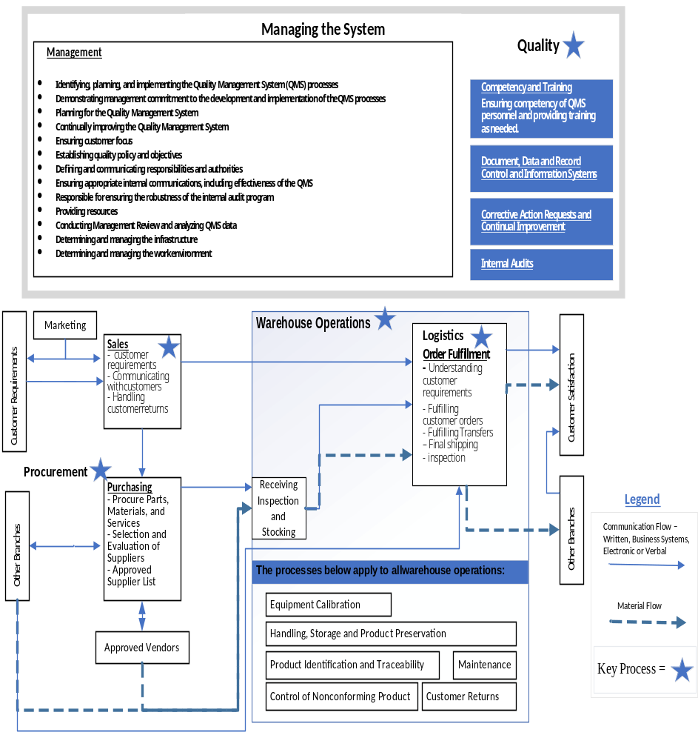

Figure 3 Organizational Chart